Example 14 : In the given mechanism the crank OA rotates at 200 rpm counter-clockwise. For the given configuration determine.
- Velocity of slider S and angular velocity of the link QB.
- Acceleration of slider S and angular acceleration of the link QB.
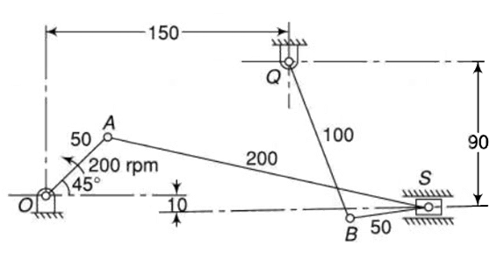
Fig. 14.1 Mechanism diagram
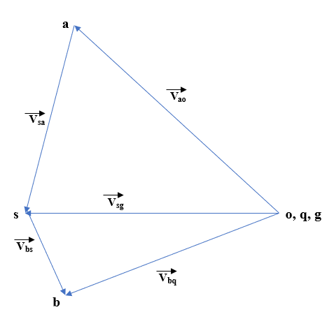  Fig 14.2 velocity diagram | 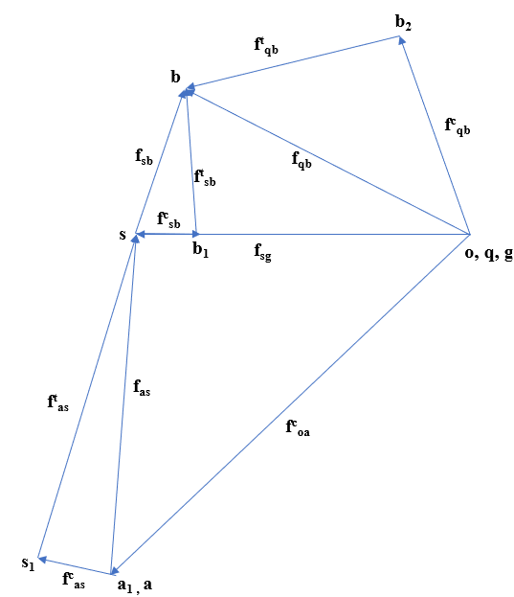  Fig 14.3 acceleration diagram

Diagrams are not to the scale. All dimension in mm.
Steps for velocity diagram :
- $v_{ao}=\frac{2π×200×0.05}{60}=1.047\frac{m}{s}$
- Scale – 1cm of velocity diagram = 0.1047 m/s
- Mark o,q,guide fix point.
- Take $⊥$ to link AO and draw vector from O of 10 cm representing $v_{a}$
- Draw vector $v_{sa}$ $⊥$ to link AS from point ‘a’ in velocity diagram, Draw velocity vector for slider wrt guide (horizontal line). at intersection we will get s point.
- Draw vector $v_{bq}$ $⊥$ to link QB from fix point and $V_{bs}$ $⊥$ to link BS from point s. at intersection we will get b point.
Velocity of slider = 0.9529 $\frac{m}{s}$ , angular velocity of QB = 9.73 rad/s

Steps for acceleration diagram :
- $\frac{V_{ao}^{2}}{AO}=\frac{{\left(1.047\right)}^{2}}{0.05}=21.93$ $\frac{m}{s^{2}}$
- Scale – 1 cm of acceleration diagram = 2.193 $\frac{m}{s^{2}}$
- Mark o,q,g fix point.
- Draw centrifugal acceleration vector of 10cm ||OA from fix point. Here $α_{oa}=0$ so tangential acceleration of oa is zero. So mark $a_{1}$ as a.
- for $f_{as}^{C}$ draw $as_{1}$ ||AS from a, and from $s_{1}$ draw $⊥as_{1}$ for $f_{as}^{t}$
- draw acceleration vector for slider wrt guide. Intersection of $f_{as}^{t}$ and $f_{sg}$ will give s point in acceleration diagram.
- For $f_{sb}^{C}$ draw $sb_{1}$ ||SB from s, from $b_{1}$ draw $⊥sb_{1}$ representing $f_{sb}^{t}$.
- Draw centrifugal acceleration vector $qb_{2}$ from fix point then draw $⊥$
from $b_{2}$ for tangential component.
- Locate b point at intersection of $f_{sb}^{t}$ and $f_{qb}^{t}$.
Acceleration of slider S= 17.544 $\frac{m}{s^{2}}$
angular acceleration of QB = 140.352 rad/s^2

Sr. No. | vector | Magnitude (m/s^2) | direction | sense
1. | $$f_{oa}^{C} or oa_{1}$$  $$f_{oa}^{t} or a_{1}a$$ | $$\frac{V_{ao}^{2}}{AO}=\frac{{\left(1.047\right)}^{2}}{0.05}=21.93$$  $α_{oa}$OA = 0 | || OA  $⊥$ OA | $→$ O  At $a_{1}$ $⊥$o$a_{1}$
2. | $$f_{as}^{C} or as_{1}$$  $$f_{as}^{t} or s_{1}s$$ | $$\frac{V_{as}^{2}}{AS}=\frac{{\left(0.722\right)}^{2}}{0.2}=2.61$$  $α_{as}$AS = 15.351 | || AS  $⊥$AS | $→$ A  At $s_{1}$ $⊥as_{1}$
3. | $$f_{sb}^{C} or sb_{1}$$  $$f_{sb}^{t} or b_{1}b$$ | $$\frac{V_{sb}^{2}}{SB}=\frac{{\left(0.293\right)}^{2}}{0.05}=1.719$$  $α_{sb}SB$ = 4.386 | || SB  $⊥$ SB | $→$ S  At $b_{1}$ $⊥sb_{1}$
4. | $$f_{qb}^{C} or qb_{2}$$  $$f_{qb}^{t} or b_{2}b$$ | $$\frac{V_{qb}^{2}}{QB}=\frac{{\left(0.973\right)}^{2}}{0.1}=9.484$$  $α_{qb}QB$ = 14.0352 | || QB  $⊥$QB | $→$ Q  At $b_{2}$ $⊥qb_{2}$
5. | $$f_{sg}^{C} or sg$$ | 8 cm * 2.193 = 17.544 | - | -
Table 14.1

